Single-Word Appositive

🔹 What is Single-Word Appositive?
# Source: AI Source: Provided by: [Data Path: Persons Table -> ID Column: 1, Name_En Column: Motasem Essam] -> From: [Chatgpt (GPT‑5 Mini)] on [8/7/2025]
A single-word appositive is a single noun or pronoun placed next to another noun to rename or identify it more specifically. It functions just like a longer appositive phrase but contains only one word.

🔸 Key Features:
# Source: AI Source: Provided by: [Data Path: Persons Table -> ID Column: 1, Name_En Column: Motasem Essam] -> From: [Chatgpt (GPT‑5 Mini)] on [8/7/2025]

Feature | Explanation
One Word | The appositive is a single noun or pronoun
Renames a Noun | It gives more specific identification to the noun it follows
Punctuation | May or may not require commas, depending on essentiality

🔸 Examples:
# Source: AI Source: Provided by: [Data Path: Persons Table -> ID Column: 1, Name_En Column: Motasem Essam] -> From: [Chatgpt (GPT‑5 Mini)] on [8/7/2025]
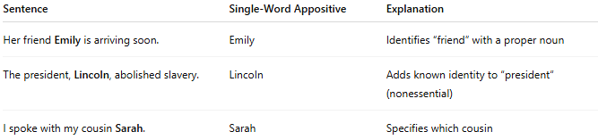
Sentence | Single-Word Appositive | Explanation
Her friend Emily is arriving soon. | Emily | Identifies “friend” with a proper noun
The president, Lincoln, abolished slavery. | Lincoln | Adds known identity to “president” (nonessential)
I spoke with my cousin Sarah. | Sarah | Specifies which cousin

🔸 Note:
# Source: AI Source: Provided by: [Data Path: Persons Table -> ID Column: 1, Name_En Column: Motasem Essam] -> From: [Chatgpt (GPT‑5 Mini)] on [8/7/2025]
- If the appositive is nonessential, use commas:
  - My teacher, Mr. Jones, gave us homework.
- If it's essential, do not use commas:
  - The poet Shakespeare wrote many plays.

